**Practical 1) Creating a account, repository on GitHub and cloning repository in GitHub page.**

1. **Creating a account on GitHub-**

**Steps**-

1. Go to GitHub website.
2. Click on **sign up**.



1. Fill up the requirements.
2. Verify the g-mail account with given code.

**Account created**

1. **Creating a repository**

Steps-

1. Sign in in GitHub.
2. Click on **new** button.
3. 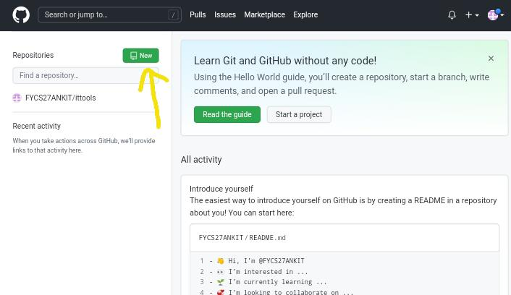Give the name of repository.

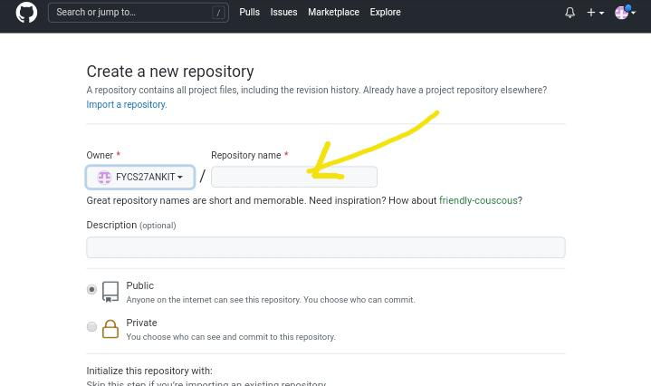

1. Click on **create repository**.

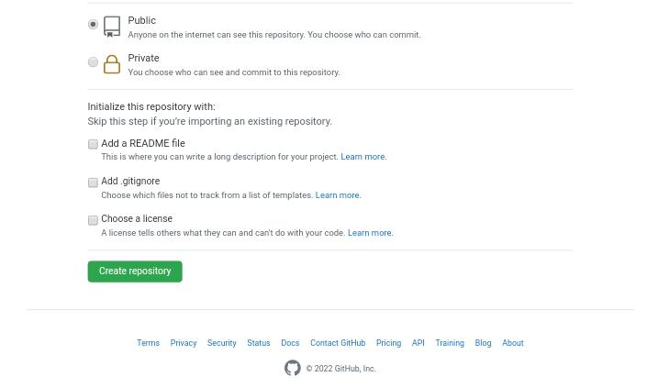

Repository created

C) **Cloning a repository**

To cloning a repository, copy the link mentioned as below and paste to users.

Repository will be clone 